Cashew pictures

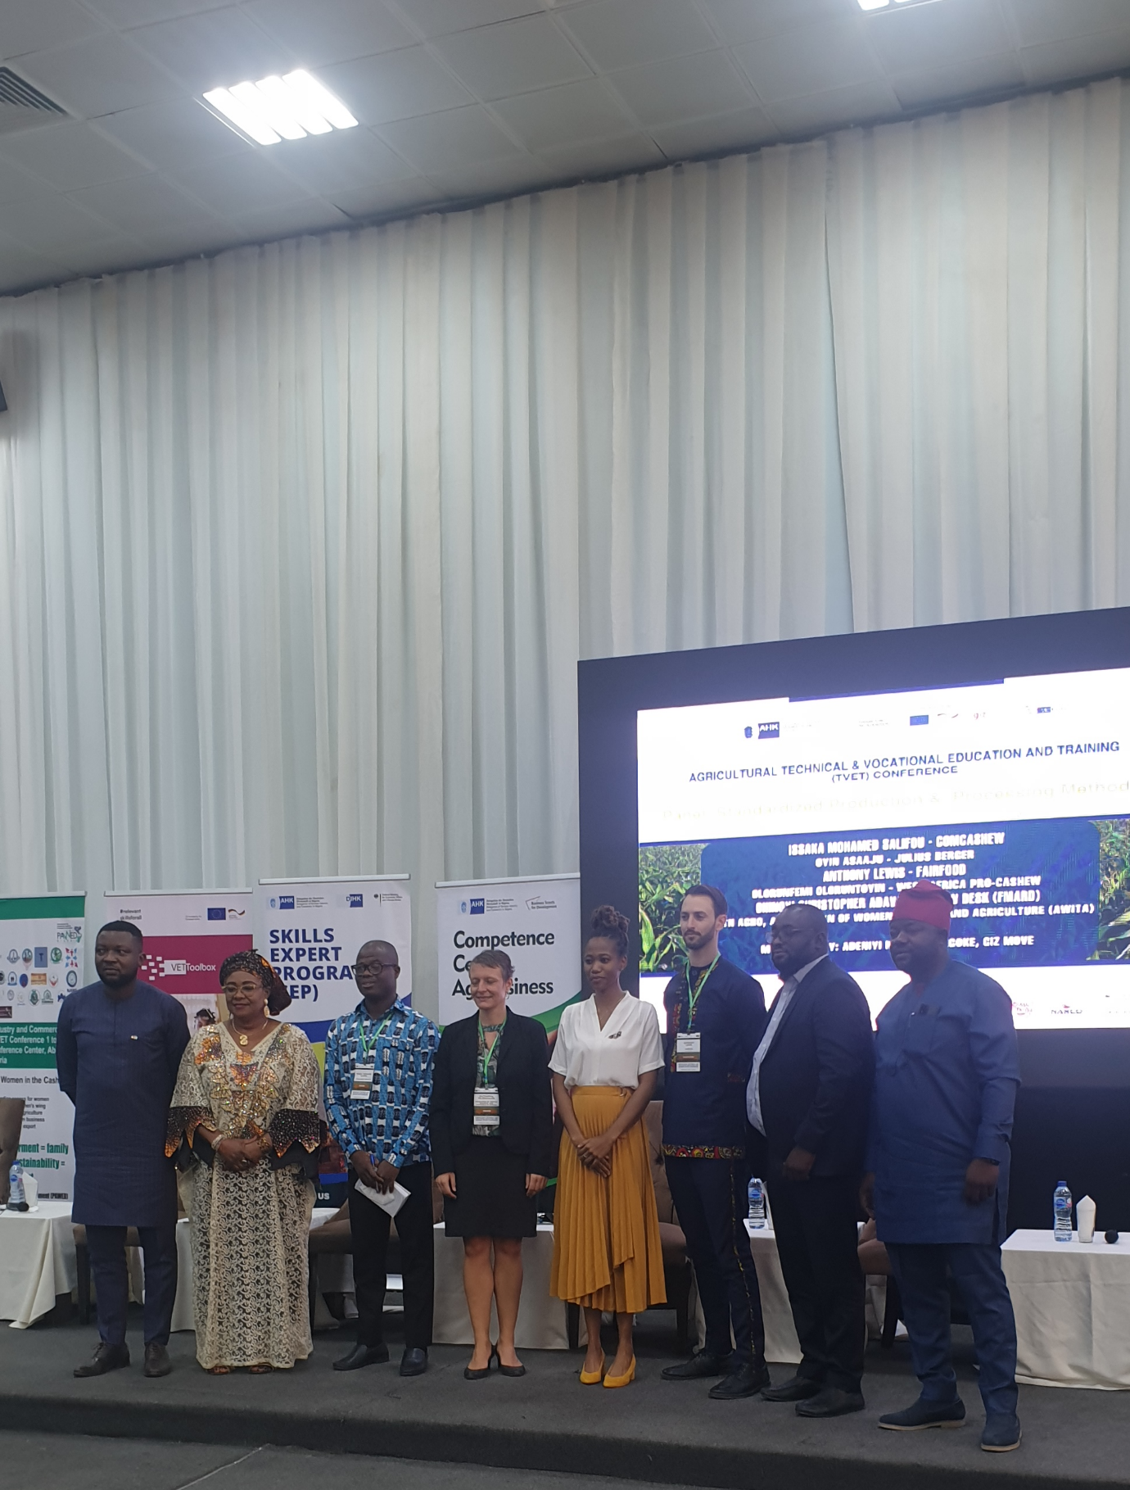

**L-R: Adeniyi Kazeem Adegoke (Panel moderator); Mrs Ruth Agbo, President, the Association of Women in Trade and Agriculture (AWITA); Issaka Mohamed Salifou of ComCashew Initiative; the Head of Corporation, EU Delegation, Delegation of German Industry and Commerce in Nigeria, Ms Cecil Tassin-Pelzer; Julius Berger’s Ms Asaaju Oyindamola; Anthony Lewis of Fairfood; Olorunfemi Oloruntoyin, Country Director, USDA West Africa PRO-Cashew; and Head Cashew Desk, Federal Ministry of Agriculture and Rural Development, Ohinoyi Christopher Adava at the TVET Cashew conference in Abuja recently**

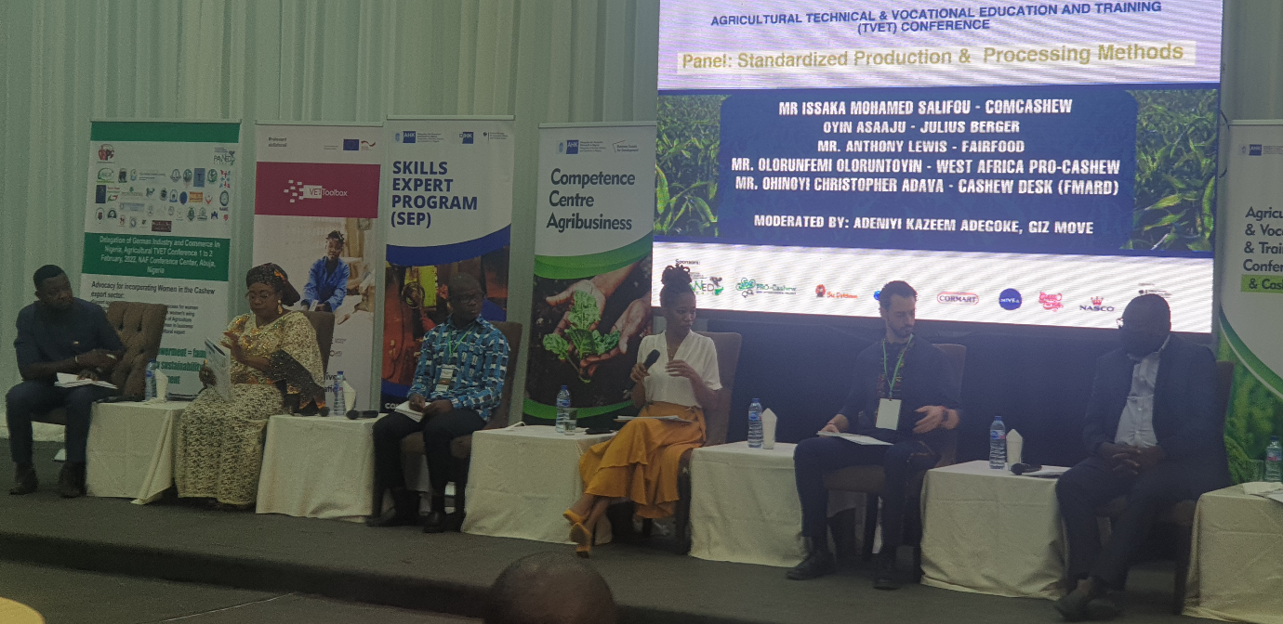

**Julius Berger’s Cashew Project’s Commodity and Marketing Manager, Oyindamola Asaaju (middle and with the microphone) making a point during the panel session on Standardized Production & Processing Methods at TVET Cashew Conference in Abuja recently**